Comparative Morphology Practical – March 2025
Key Terms
Morphology – The study of biological form, shape, or structure.
Comparative morphology – Examining variation in morphology across individuals, life stages, or species
Biomechanics – Study of the structure and function of biological systems
Artiodactyls – Even-toed ungulates including Cervidae, Bovidae, and Giraffidae.
Metapodial – Long bones of the hands (metacarpals) and feet (metatarsals) which connect the toes/fingers to the leg/arm bones
Epiphysis – The end part of a long bone which articulates with other bones to form a joint.

Introduction
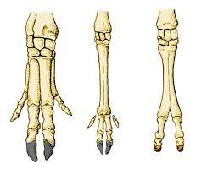
Fig 1. Left: Pig – mt. 2-5, unfused; Middle: Camel – mt. 3-4 fused; Right: Deer – mt. 3-4 fused.
Comparative morphology can provide zoologists and biologists insights into the ecology, development, and evolutionary history of living and extinct organisms. There is a particular interest in the comparative morphology of bones because these elements are most likely to be preserved in the fossil record, offering an opportunity to study deep-time evolution. In this lab, we will learn how an understanding of comparative morphology and biomechanics can provide evolutionary insights.
Many artiodactyls share the evolved characteristic of fused third and fourth metapodials in both the forelimb and the hindlimb (Fig 1.). Fusion of hand and foot bones is associated with elongation of limbs in running mammals. Here will investigate morphological variation and biomechanics of metacarpals in artiodactyls.
Metacarpal biomechanics - The breadth of the shaft of the metacarpal relative to its length is related to the mode of locomotion and to the extent of elongation of the limbs in the different animal groups. A relatively longer metacarpal indicates a more elongate limb, producing a long out-lever for rapid limb movements during running (Fig. 2). The surface area of the joint of the metacarpal is designed to carry a large proportion of the animal’s body weight, so heavier animals are expected to have larger epiphyses to distribute the load.
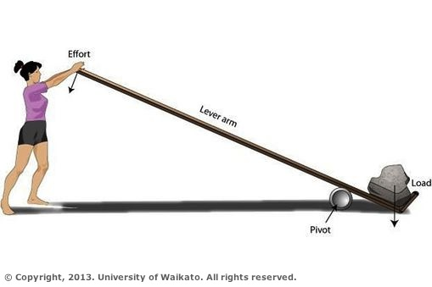
Fig. 2. A longer lever arm will produce more mechanical force when effort is applied as an in-lever (woman pushes down, rock moves), and more rapid movement when moment is applied as an out-lever (rock pushes down, woman moves).

Intended Learning Outcomes
- Recognize the morphology of the metacarpal bone in various artiodactyl species
- Collect, describe, and report morphological data from osteological specimens and apply a regression analysis in excel
- Quantitatively compare variation in metacarpal morphology among species and discuss its biomechanical and evolutionary implications.

Instructions
- Specimens are provided on the tables. Only one specimen should be taken to your workstation at a time to make sure everyone has a chance to access them.
- Form teams of two-three people to work on this practical, with at least one laptop connected to the internet for each team. Each team will need a pair of callipers.
- In your teams, follow the instructions below and fill in the data you collect to the google spreadsheet linked on the blackboard page.
- Copy and paste your data over to your computer and conduct the analyses in excel – we recommend you do not use the online version of excel as it lacks some functionality.
- When you are happy with your results graphs, copy them into the ‘results’ tab in the google spreadsheet, with your team name in the title, and we can discuss them together.

Specimens
The specimens available for the lab are as follows:
- 7 large sheep (Ovis aries)
- 4 small sheep (Ovis aries)
- 3 small cows (Bos Taurus)
- 3 large cows (Bos Taurus)
- 2 moose (Alces alces)
- 1 red deer (Cervus elephas)
- 1 roe deer (Capreolus capreolus)
- 3 Giraffe (Giraffa Camelopardalis)
- Each group will need to measure 1 of each of these (8 bones total) for each task. You will need to share and coordinate with the other groups to take your measurement.
- Please note down the specimen number on your bones as you take your measurements
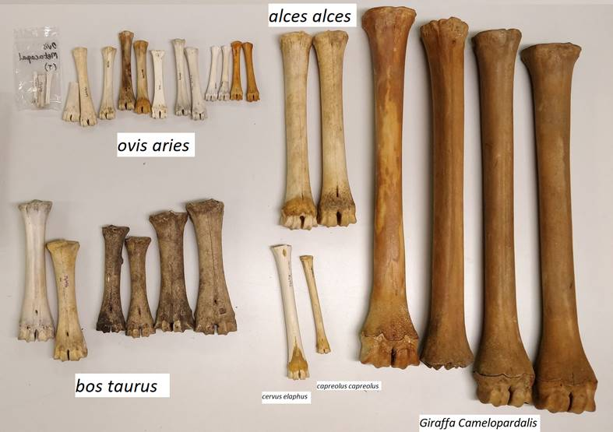

Task 1: Metacarpal Shape
A: Specimen examination
- Study the morphology of the metacarpal and note its features (see below).
Q1: Describe how the metacarpal bones function in the artiodactyl hand.

- Study the evolutionary relationships of ruminant artiodactyls shown below.
Q2: Using online research, define the groups cervidae, bovidae, and giraffidae.

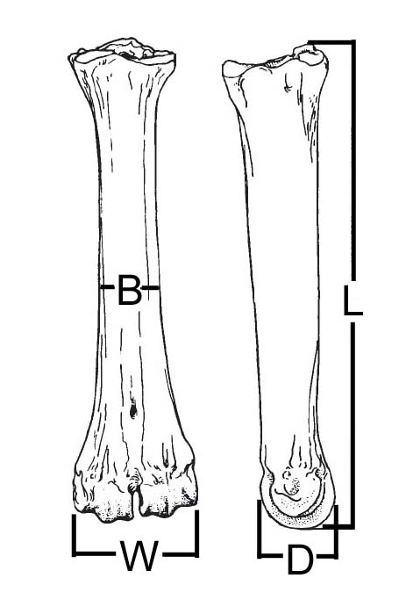
Shaft
Proximal epiphysis – articulate with hand bones
Species | L (mm) | B (mm)
Giraffa camelopardalis | 694 | 45.1
Okapia johnstoni | 325 | 30.4
Bohlinia attica | 687 | 50.3
Palaeotragus rouenii | 414 | 29.3
Canthumeryx sirtensis | 270 | 19.1
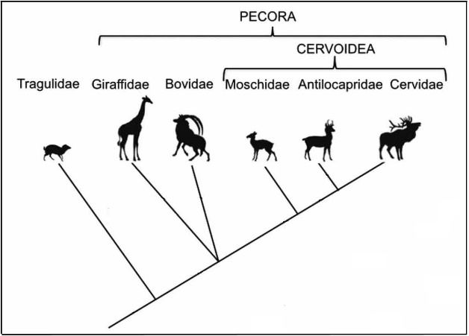
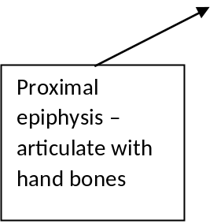
Giraffid measurements (from Rios et al., Palaeontologia Electronica 2016)
Distal epiphysis – articulate with fingers
Shaft
Ruminant Phylogeny (from Janis & Theodor, Zitteliana 2015)
Distal epiphysis – articulate with fingers

B: Data Collection
(b) Measure the maximum length (L) and midshaft breadth (B) of the metacarpal bones in the samples of cervid, bovid and giraffid specimens (for the giraffids, use the measurements in the table below in addition to your measurement of the laboratory specimen). Add them to the google spreadsheet.
Copy the data across to the excel template on your own computer for analysis
C: Data analysis
(c) Plot midshaft breadth versus maximum length as a scatterplot. Make a plot with separate series for cervid, bovid and giraffid data (see appendix for instructions).
(d) Add regression lines to your three ruminant groups, and display the slope and intercept, and r2 for the relationship.
Change the title to your team name and copy the graph into the results tab of the google spreadsheet.
Q3: How does the slope and intercept vary between these three groups? What might this mean for how their shape changes as they increase in size? What are the biomechanical implications?

Task 2: Joint Scaling
In most quadrupedal animals approximately two-thirds of the weight of the body is carried on the forelimbs. Therefore, we expect the surface area of the forelimb joints to be proportional to body mass in order to limit the stress on the animal’s joint cartilage. The area-mass relationship can be tested by estimating the areas of the joint surfaces of the distal epiphyses of the metacarpals and then plotting these areas against body mass values (the latter are taken from the literature).
A: Data collection
(a) Measure the medio-lateral width (W) and the anterior-posterior diameter (D) of the distal epiphysis and add the data to the google spreadsheet.
(b) The joint surface of the distal metacarpal epiphysis approximates to half of a cylinder, so you can calculate the surface area of this joint surface using the formula below. Use the google spreadsheet to calculate the joint surface area.
Area = W × D × π ÷ 2
Copy the data across to the excel template on your own computer for analysis
B: Data Analysis
- Plot the estimated joint surface areas against body mass as a scatterplot (see instructions in the excel template and in the Appendix).
Q1: How does joint area change as size increases? Why is this?

- Log transform the body mass and area values using the formula =log10(x). Plot log joint surface areas against log body mass as a scatterplot and fit a regression line with an equation. Answer the questions below.
Change the title to your team name and copy the graph into the results tab of the google spreadsheet.
Q2: What impact does log-transforming the data have and why might it be useful to use a log transform?

Q3: What is the slope of your regression? What does that tell you about how joint area scales? Hint: a slope of one on a log-log plot indicates that the relationship between the two variables remains the same as it scales.

APPENDIX: PLOTTING DATA IN EXCEL

To refresh the summary table (task 1)
- Click on any cell of the table (blue-grey banner)
- Select ‘PivotTable Analyze’
- Click on the arrow below ‘Refresh’
- Select ‘Refresh All’
- After this, the scatterplot should be automatically populated with your data

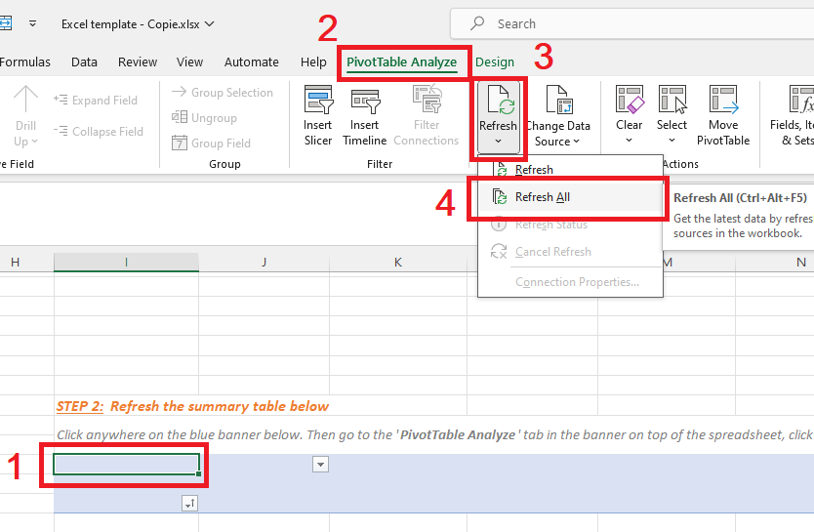

(ADDITIONAL APPENDICES)

To plot a scatterplot
- Select the x and y column of interest
- Click ‘insert’, then add scatterplot – the symbol with the dots on the bottom row



To add a regression line
- Click on one of the dots to select the series, and right click and select ‘add trendline’
- Select linear trend, then select ‘display equation on chart’

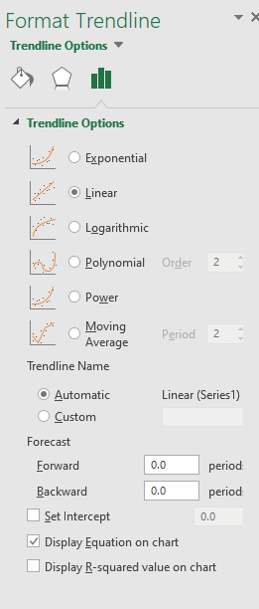

Making separate lines for groups
- Select all the data, then click data>sort
- Sort the data based on the group (bovid, cervid etc)
- Select the chart, and under design, select ‘Select data’
- In the left box, select ‘add series’ and add a series for each group
- Select the data associated with that group (e.g., bovids)
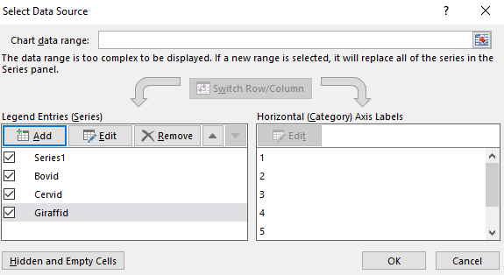
- There should now be multiple lines on the graph
- You can add separate trendlines as before.

